Name: Ashwin Yadav

Enrollment No: 232026900131

Subject: Frontend Development  
Date: 31-03-2025

Exam Type: Assignment

Q1: Make an location Tracker Application.  
Ans 1:

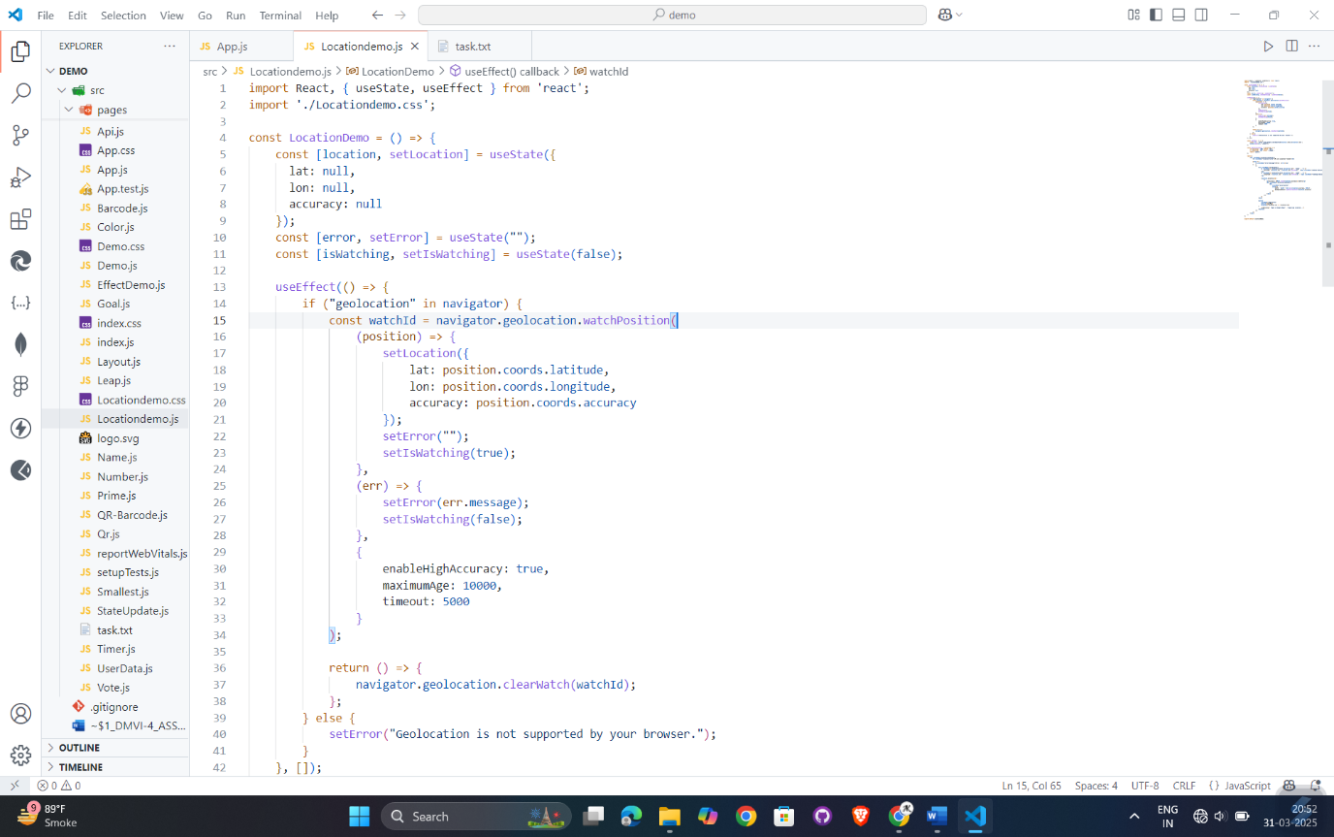

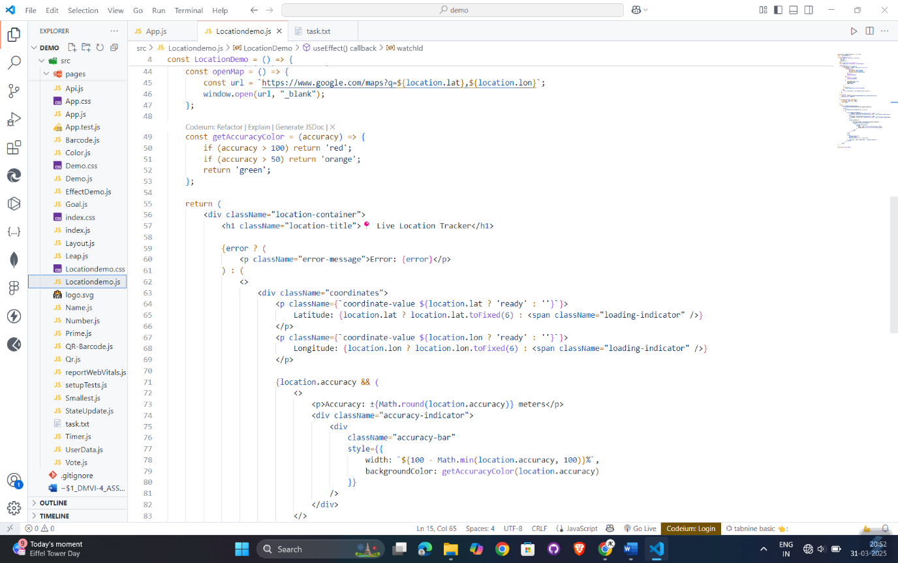

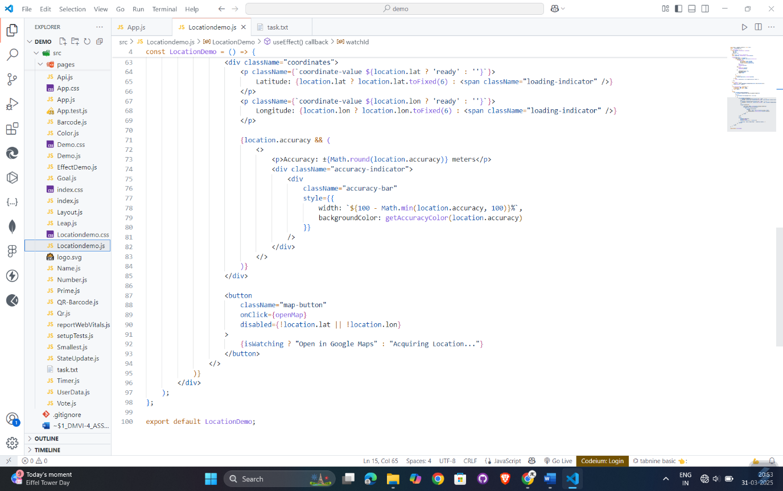

Output 1:

